Lessons learned

- Special care with ground and to avoid ground loops

- Use the external interrupt debounce (input filter in capture mode)

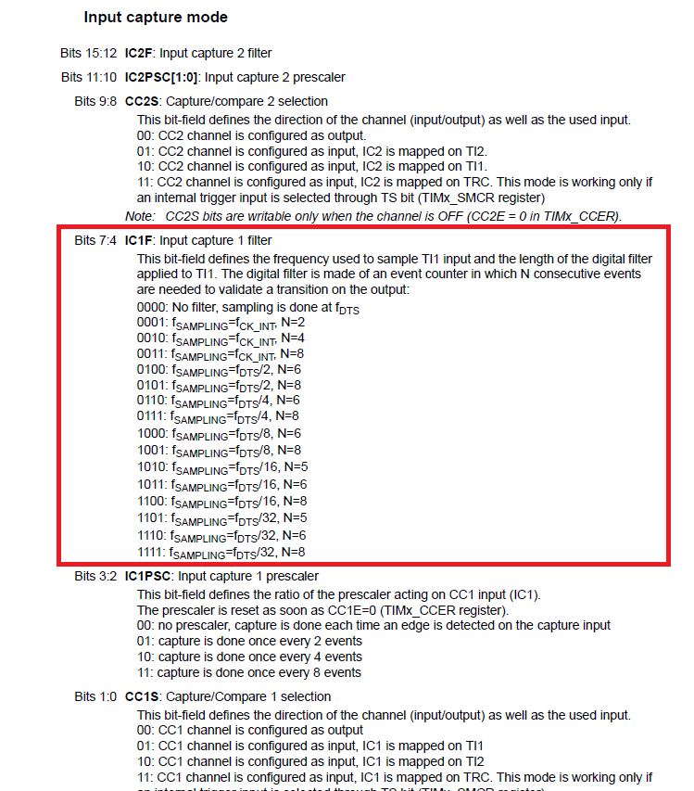

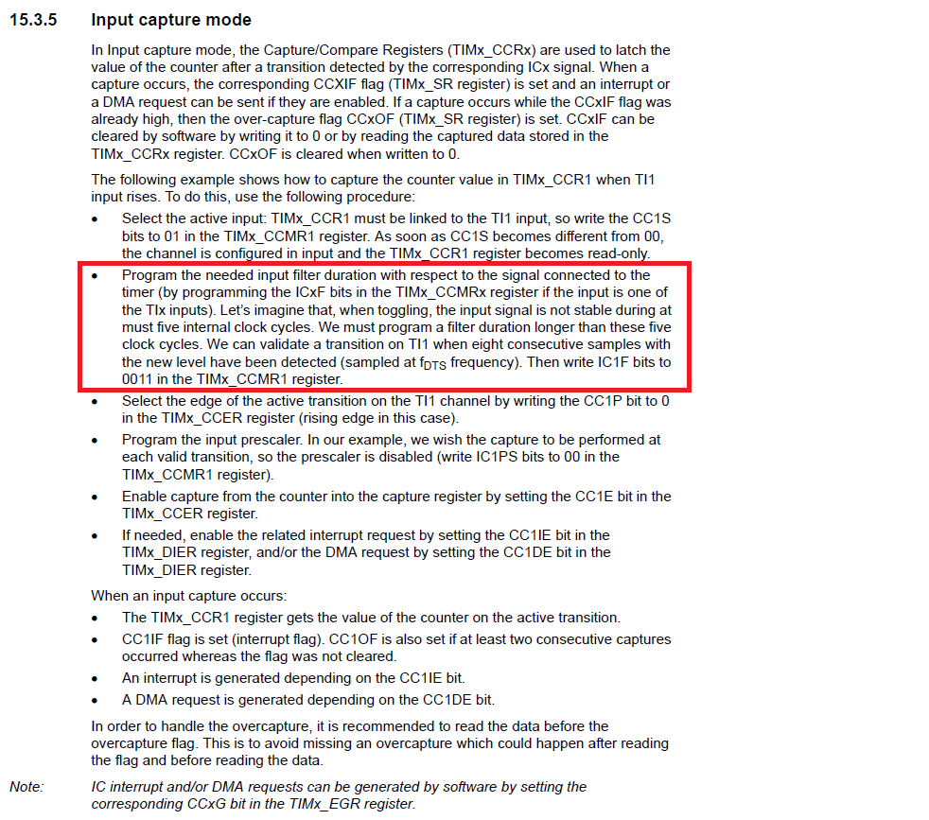

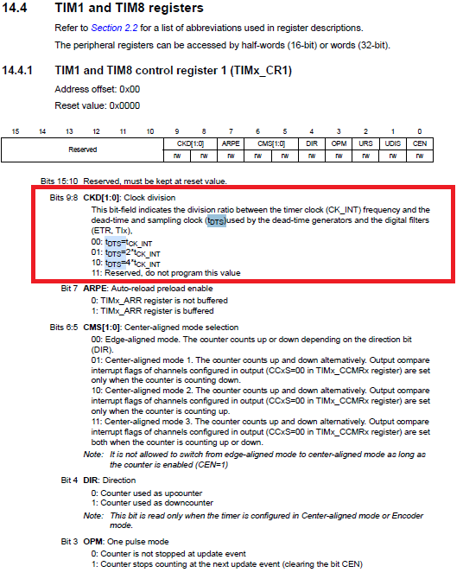

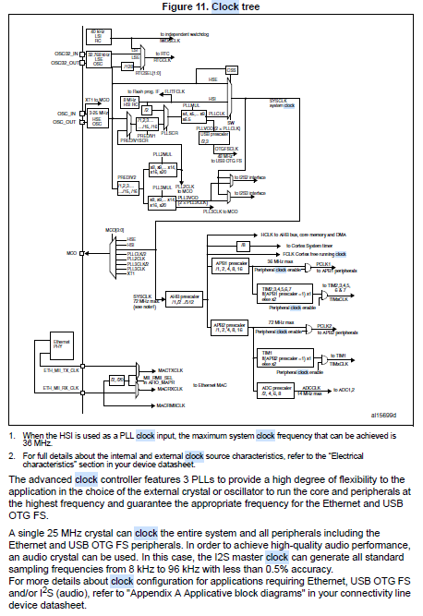

Improvements

- Research an applicable TVS diode (be able to operate very fast, signal period is approximately 20ns)

- Study SCR theory to understand what is the appropriate SCR polarization (maybe the resistors that I use is not the best for this application, the current is very high (approx. 15mA)